https://forge.tcsbank.ru/case/5431232/info
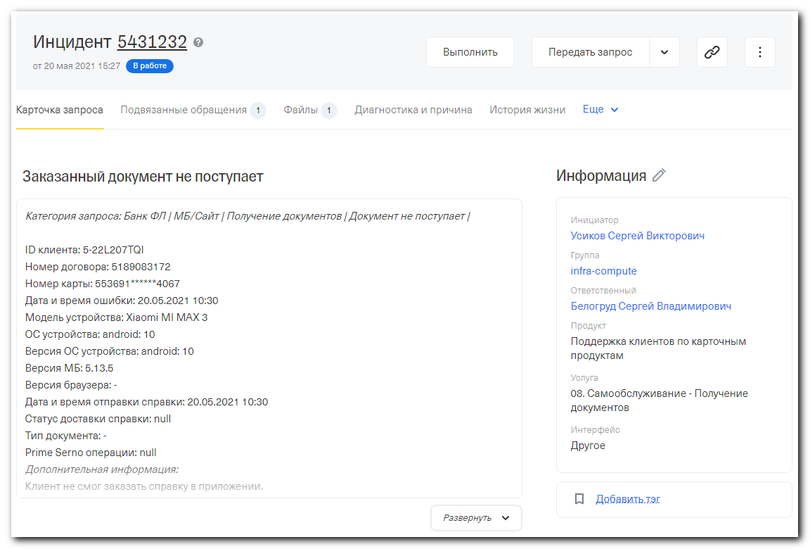

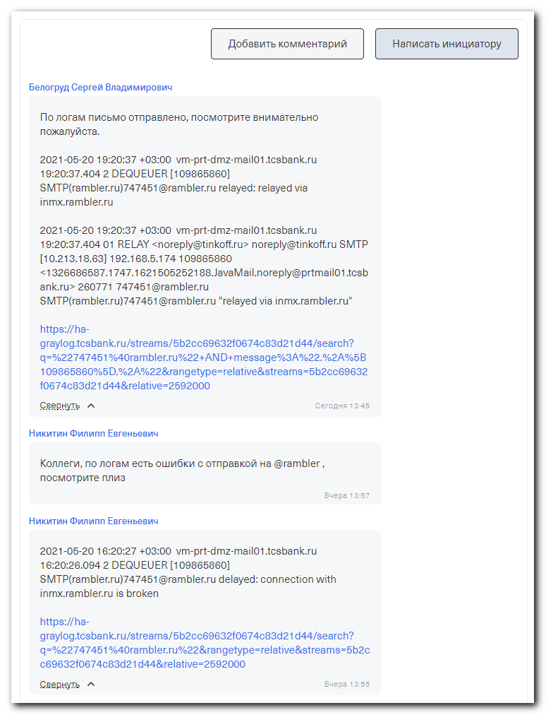

#
# After the task was resolved, I transfered the task back to Никитин Филипп (he was from the 1st line tech support).
#

#
# I went to the Graylog via URL, published in comment:
https://ha-graylog.tcsbank.ru/streams/5b2cc69632f0674c83d21d44/search?q=%22747451%40rambler.ru%22&rangetype=relative&streams=5b2cc69632f0674c83d21d44&relative=2592000

#
# I found lot of messages addressed to 747451@rambler.ru.
# The filter in the Graylog contains only "747451@rambler.ru".
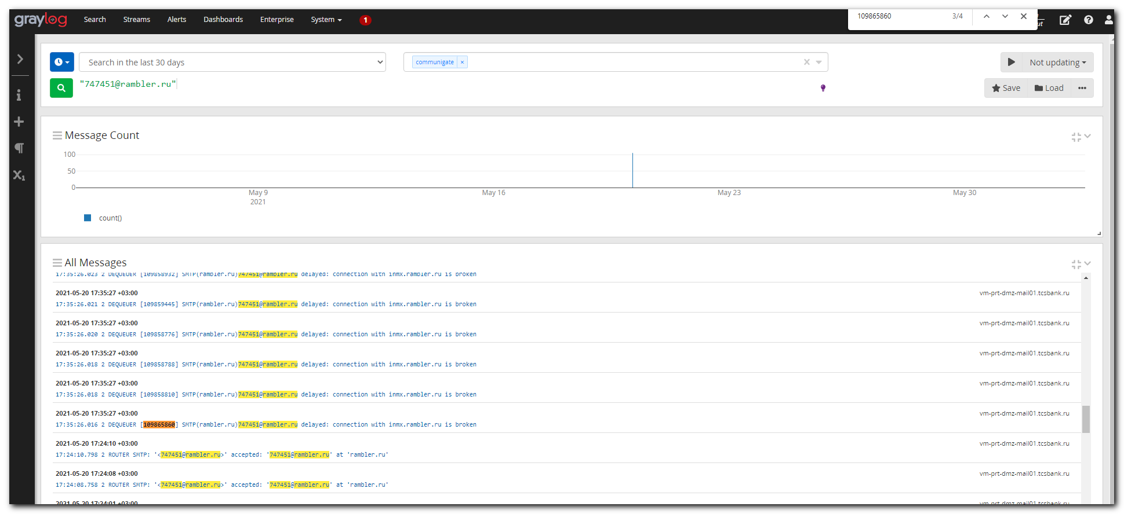

# Let's make more precise filter. Only for the mail with mail queue identificator = 109865860
# I will make it exactly from already found records about this email.
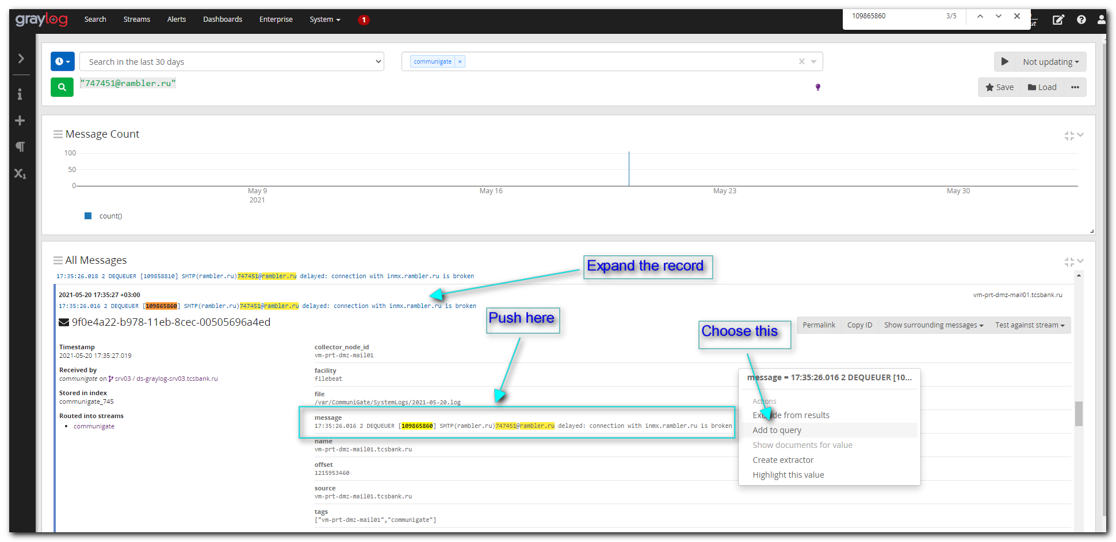

# At this moment I have a filter for only one email with defined message text.
# "747451@rambler.ru" AND message:"17:35:26.016 2 DEQUEUER [109865860] SMTP(rambler.ru)747451@rambler.ru delayed: connection with inmx.rambler.ru is broken"
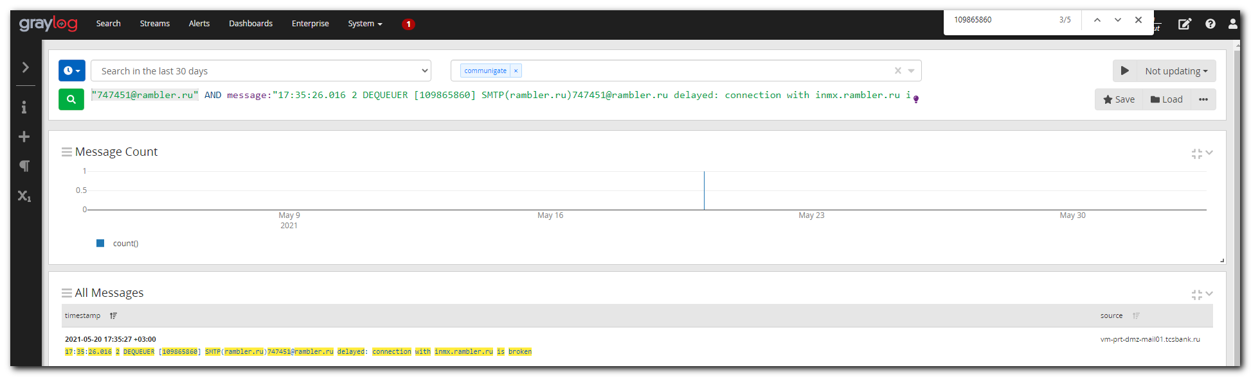

#
# Then, I created followed filter for all messages with queue identifier = 109865860.
# I added "AND" and tried to find exactly neede mail via its queue number [109865860]. And I removed everything else and replaced it with ".*".
#
https://ha-graylog.tcsbank.ru/streams/5b2cc69632f0674c83d21d44/search?q=%22747451%40rambler.ru%22+AND+message%3A%22.%2A%5B109865860%5D.%2A%22&rangetype=relative&streams=5b2cc69632f0674c83d21d44&relative=2592000

"747451@rambler.ru" AND message:".*[109865860].*"

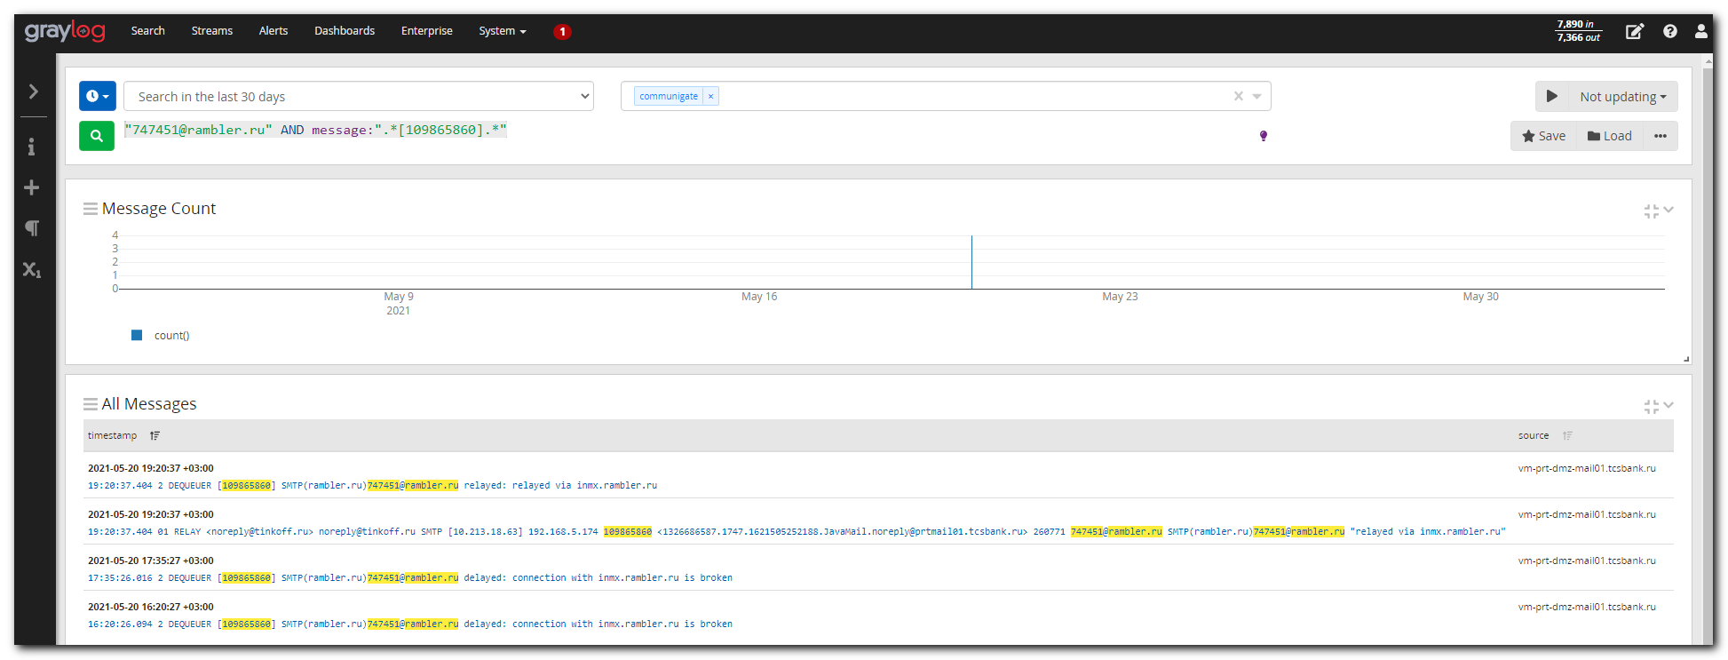

2021-05-20 19:20:37 +03:00 vm-prt-dmz-mail01.tcsbank.ru
19:20:37.404 2 DEQUEUER [109865860] SMTP(rambler.ru)747451@rambler.ru relayed: relayed via inmx.rambler.ru

2021-05-20 19:20:37 +03:00 vm-prt-dmz-mail01.tcsbank.ru
19:20:37.404 01 RELAY <noreply@tinkoff.ru> noreply@tinkoff.ru SMTP [10.213.18.63] 192.168.5.174 109865860 <1326686587.1747.1621505252188.JavaMail.noreply@prtmail01.tcsbank.ru> 260771 747451@rambler.ru SMTP(rambler.ru)747451@rambler.ru "relayed via inmx.rambler.ru"

2021-05-20 17:35:27 +03:00 vm-prt-dmz-mail01.tcsbank.ru
17:35:26.016 2 DEQUEUER [109865860] SMTP(rambler.ru)747451@rambler.ru delayed: connection with inmx.rambler.ru is broken

2021-05-20 16:20:27 +03:00 vm-prt-dmz-mail01.tcsbank.ru
16:20:26.094 2 DEQUEUER [109865860] SMTP(rambler.ru)747451@rambler.ru delayed: connection with inmx.rambler.ru is broken

#
# 20210602
# https://tinkoff.slack.com/archives/CTRAME9LP/p1622629151048100
#
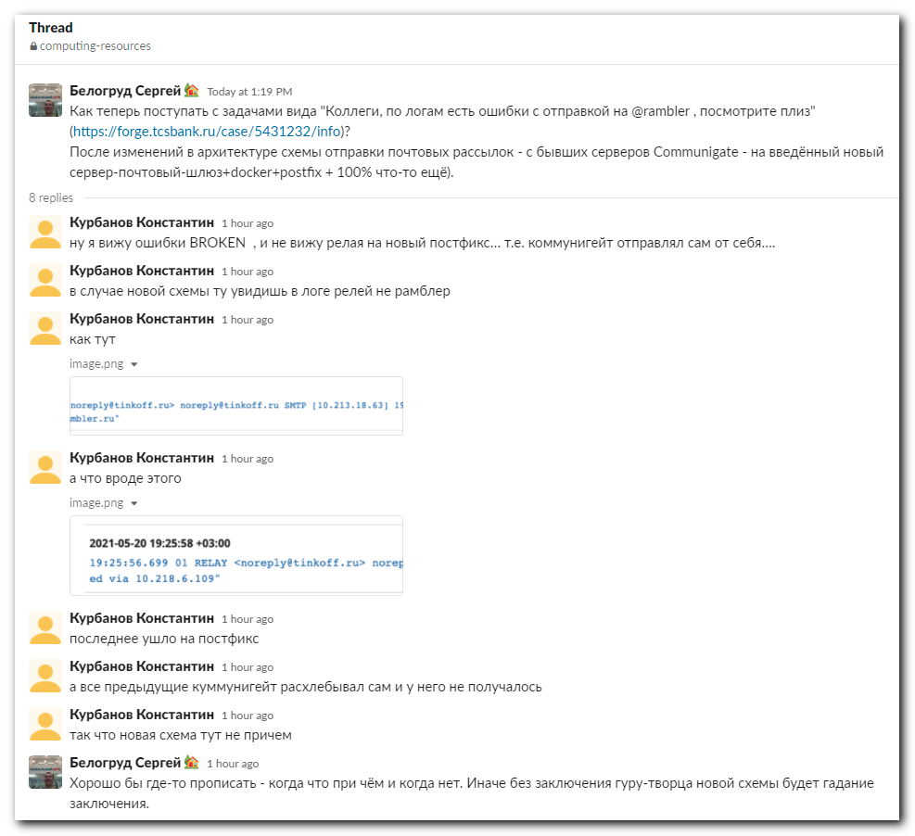

# Here is a new relay, that was made by Kurbanov Konstantin.
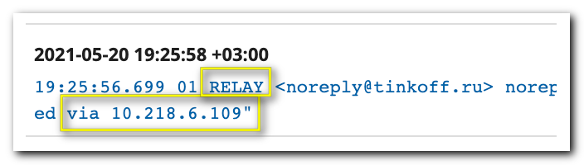

# Here are some advises about filter and regular expressions.
#
https://docs.graylog.org/en/3.3/pages/searching/query_language.html
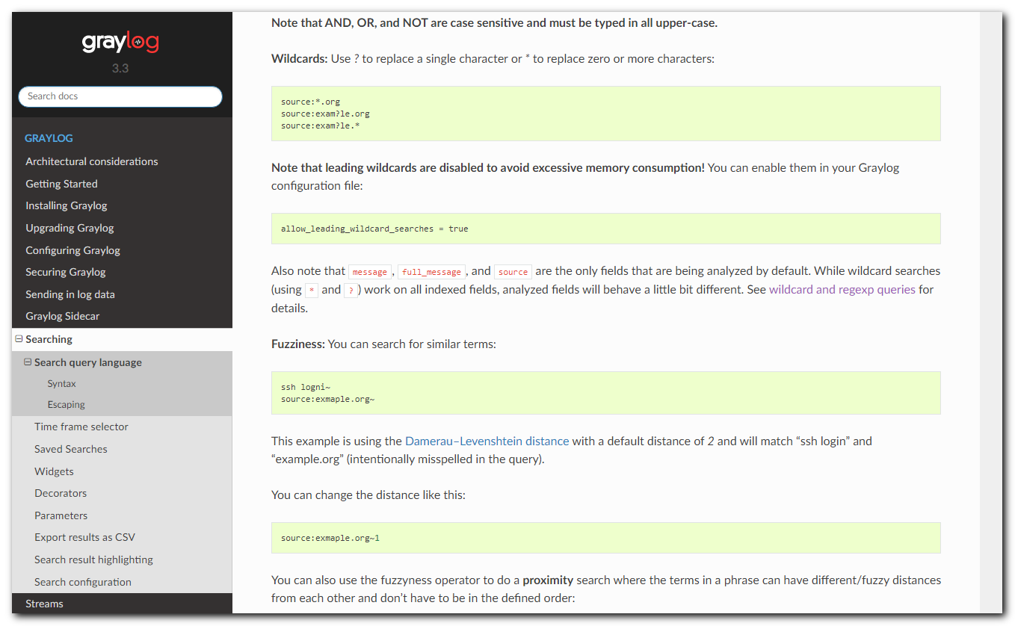

https://www.elastic.co/guide/en/elasticsearch/guide/2.x/_wildcard_and_regexp_queries.html
